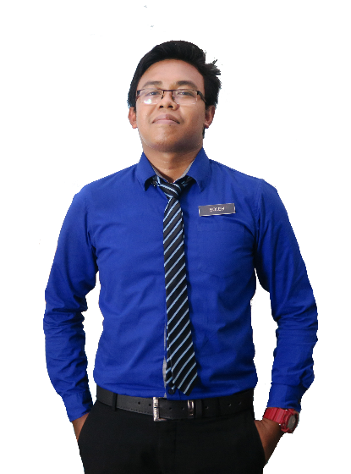

**EN. MUHAMAD SOLEH HUDIN**

Principal, SMK Bandar Baru Sungai Buloh

Phone: 06-4349162Email: smkbbsb@gmai.com

Principal, SMK Bandar Baru Sungai Buloh

Phone: 06-4349162Email: smkbbsb@gmai.com

**EN. MUHAMAD SOLEH HUDIN**

**REFERENCE**

**PERSONAL SKILLS**

Hard work

Management

Teamwork

Creative

Communication

Adobe After Effect

Adobe Photoshop CS6

Microsoft Excel

Microsoft Word

**SKILLS**

* Graphic Design Award 2015, Kuala Lumpur
* Anugerah Guru Cemerlang SMK Bandar Baru Sungai Buloh 2016
* Larian Hari Sukan Negara 2016, UiTM Kampus Puncak Alam
* Volunteer for SUKMA 18, Pahang Darul Makmur
* Creative and Innovation Awards 2017

**ACHIEVEMENT**

**SEKOLAH MEN KEB KUALA TEKAL, PAHANG**

**Teacher**

2013-2015

Teach at undergraduate and graduate level in areas allocated by the Head of Department and reviewed from time to time by the Head of Department. Carry out research and produce publications, or other research outputs, in line with personal objectives agreed in the Staff review process.

2013-2015

Teach at undergraduate and graduate level in areas allocated by the Head of Department and reviewed from time to time by the Head of Department. Carry out research and produce publications, or other research outputs, in line with personal objectives agreed in the Staff review process.

**Teacher**

**SEKOLAH MEN KEB BANDAR BARU SG BULOH**

Teach at undergraduate and graduate level in areas allocated by the Head of Department and reviewed from time to time by the Head of Department. Carry out research and produce publications, or other research outputs, in line with personal objectives agreed in the Staff review process.

**Lecturer**

**UNIVERSITI TEKNOLOGI MARA SHAH ALAM, SELANGOR**

Jan 2013-Present

**SEKOLAH MEN KEB BANDAR BARU SUNGAI BULOH**

**UNIVERSITI TEKNOLOGI MARA KAMPUS PUNCAK ALAM**

Master of Education in Chemistry

CGPA: 3.93

**EXPERIENCE**

Sijil Pelajaran Malaysia

2012-2014

2012-2014

2012-2014

**KOLEJ MATRIKULASI KEDAH, CHANGLUN**

Science Stream (Module II)

CGPA: 3.93

Bachelor of Education in Science (Hons) Chemistry

CGPA: 3.93

**UNIVERSITI TEKNOLOGI MARA SHAH ALAM, SELANGOR**

Jan 2013-Present

**EDUCATION**

Master’s degree in Science with four years’ experience teaching high school Science, Chemistry, and Additional mathematic. Certification in teaching Science and also professional in graphic design and video editor.

Creative Resume, 74000 Bandar Puncak Alam, Selangor

013-2805916 | resumecreative@yahoo.com

**TEACHER & GRAPHIC DESIGNER**

**MUHD SOLEH**

**ABOUT ME**